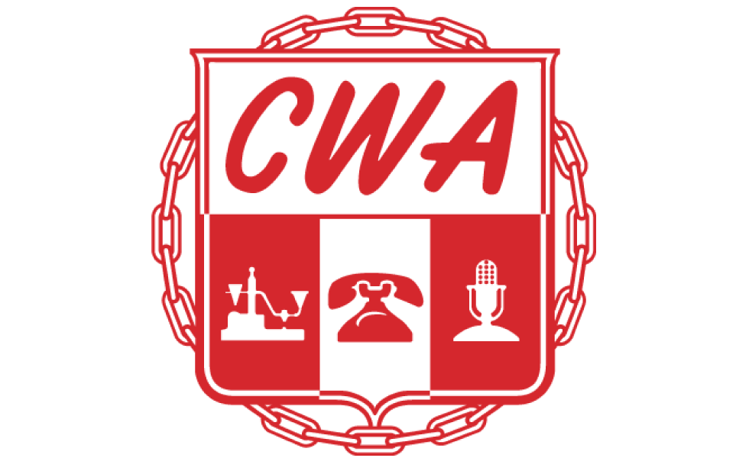Communications Workers of America Local 3106, AFL-CIO

RECORD OF INFORMAL GRIEVANCE SETTLEMENT

Grievant Name: | {{ grievant_name }} | Grievance # | {{ grievance_number }}

Date of Informal Meeting with Management: |  |  |  | {{ informal_meeting_date }}
Company Representative in Attendance: |  |  | {{ company_rep_attending }}
Union Representative in Attendance: |  | {{ union_rep_attending }}
Article: | {{ issue_article }}
Issue:
{{ row.text }}

Settlement:

{{ row.text }}

Signer Role | Signature | Date
Company Representative | {{ Sig_es_:signer1:signature }} | {{ Dte_es_:signer1:date }}
Steward | {{ Sig_es_:signer2:signature }} | {{ Dte_es_:signer2:date }}

